EC Declaration of Performance

1. Unique identification code of the product-type:
Forte
Unique batch code is on packaging

2. Intended use/es:
General Purpose rendering / plastering mortar.

3. Manufacturer:
Lime Green Products Ltd
Coates Kilns
Stretton Road
Much Wenlock
Shropshire
TF13 6DG

4. Authorised representative:
N/A

5. System/s of AVCP:
System 4

6a. Harmonised standard:
EN998-1:2010

6b. European Assessment Document:
N/A

7. Declared Performance
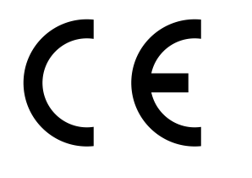

Lime Green Products Ltd, Coates Kilns, Stretton Road, Much Wenlock, Shropshire, TF13 6DG

16

Forte

EN 998–1:2010

Factory Made General Purpose Rendering and plastering mortar for internal and external use

Reaction to fire: Class A1

Strength Class CSIII

Adhesion and fracture pattern: >0.15 FP: B

Capillary Water absorption: W0

Water vapour Permeability coefficient. µ ≤ 15

Mean thermal conductivity λ10,dry [W/mK] 0.82

Durability: (against freeze/thaw): evaluation based on provisions valid in the
intended place of use of the mortar

The performance of the product identified above is in conformity with the set of declared performance/s. This declaration of performance is issued, in accordance with Regulation (EU) No 305/2011, under the sole responsibility of the manufacturer identified above.

Date 2/8/16

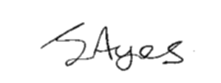
Signed

J Ayres – Director

